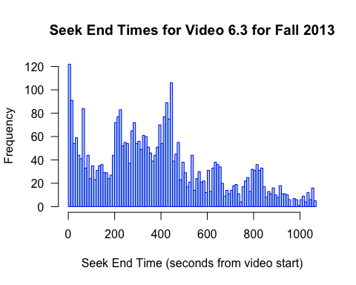

Video by Eric Lander Length of the video: 17:49

From the topic Protein structure

Followed by 1 Test yourself question

Seek peaks from 200 seconds to 500 seconds:

Topics covered:

Amino acids and abbreviations

Division of Amino acids into 4 groups:

1) Polar uncharged 2) Polar charged (+) 3)Polar charged (-)

4)Hydrophobic

Highest peek at 7:33- Summary of different types of amino acid groups, followed by the exception cases (special group) – Proline, glycine, cysteine

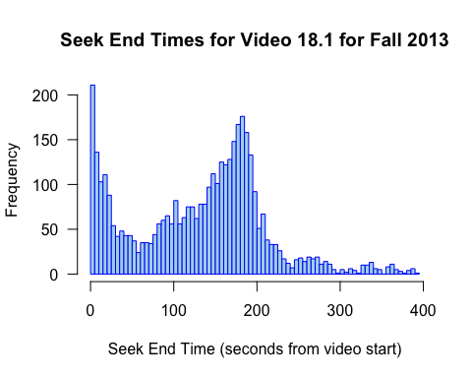

2) Name of the video - Lab18.1-Yeast In The Lab Number of seeks- 3144

Length of the video: 6:32

This is a lab video that talks about the budding yeast. Video shows

growing yeast colonies in a petri dish.

Seek peaks from 145 seconds to 200 seconds (Broad Peeks)

Topics covered:

Preparation of Agar media

Streaking of yeast on petri dish

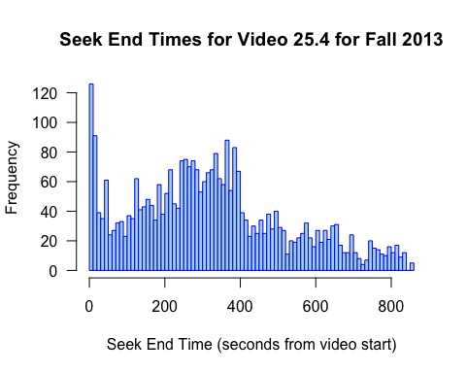

3)Name of the video -25.4-PCR Number of seeks- 3042

Video by Eric Lander Length of the video: 14:16

It is part of the Recombinant DNA 2 section. Video explains

process of polymerase chain reaction.

It is followed by one test

yourself question.

Topics covered around 200 to 420 seconds

Extracting gene

Amplifying gene

Process of PCR

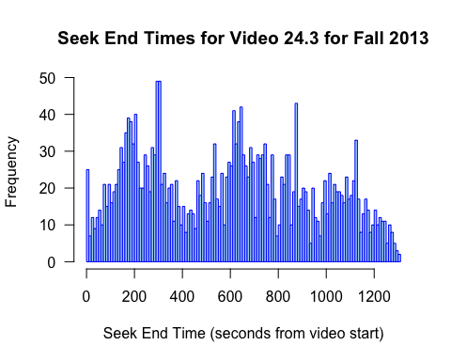

4) Name of the video – 24.3 Cutting And Pasting DNA

Number of seeks- 2458

Video by Eric Lander Length of the video: 21:42

From the topic Recombinant DNA 1

Followed by 2 Test yourself questions

Restriction enzyme and how it works

EcoR1 site

Making an enzyme

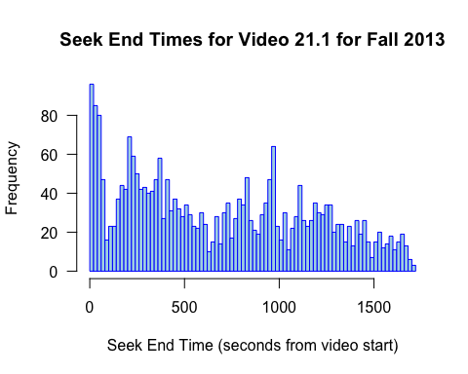

5) Name of the video - 21.1-ReplicationInDifferentOrganisms

Number of seeks- 2373

Video by Eric Lander Length of the video: 28:43

Followed by 1 Test yourself question

From the topic Introns

Summary of Transcription and translation

Central Dogma

Prokaryotes and Eukaryotes- number of chromosomes, replication process

DNA Polymerase and RNA Polymerase

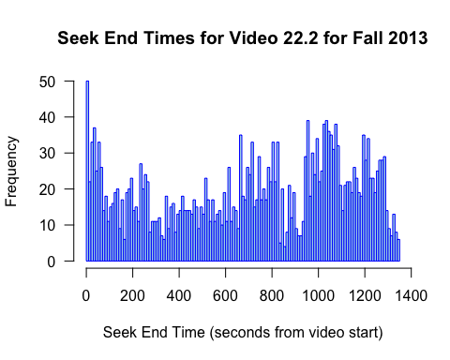

6) Name of the video - 22.2-Beta Globin Mutations Number of seeks- 2369

Video by Eric Lander Length of the video: 22:34

Followed by 1 Test yourself question

From the topic Mutations

Missense Non-conservative Substitution

Frameshift Mutations

Transposons

Poly A site

Silent substitution

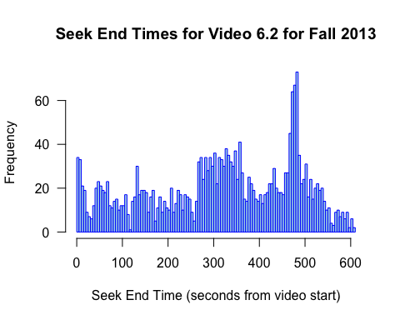

7) Name of the video - 06.2- Primary Structure Of Proteins Number of seeks- 2184

Video by Eric Lander Length of the video: 10:08

Followed by 1 Test yourself question

From the topic Protein Structure

Fuction of protein, structure of protein , side chains

Peptide bonds – side chains and rotation